

《学术用途英语二级》课程期末小组报告
刀片电池：突破美国新能源汽车电池供应链制裁
BYD Blade Battery: Overcoming U.S. EV Battery Supply Chain Restrictions

学 院： | 鲍曼学院
专 业： | 自动化
学生姓名： | 莫天皓 韦宇阳
学 号： | 1120253612 1120252702
指导教师： | 陈颖秀

2026 年 6 月 1 日
BYD Blade Battery: Overcoming U.S. EV Battery Supply Chain Restrictions

Abstract
In recent years, U.S. trade and industrial policies have imposed stringent restrictions on Chinese electric vehicles and battery products to curb China’s dominance in clean-energy supply chains. Through measures such as battery tariffs and the Foreign Entity of Concern (FEOC) rules, these policies have limited China’s access to advanced materials, manufacturing equipment, and international markets. This report examines how BYD developed the Blade Battery technology and how this innovation has helped China’s EV industry overcome technological bottlenecks and mitigate external pressures.
In this report we first review relevant battery technologies and identify key challenges facing the battery industry using literature review, case study, and comparative analysis. The Blade Battery adopts a compact design based on long, flat lithium iron phosphate (LFP) cells, offering advantages in safety, durability, and space utilization.
Then we further analyze BYD’s independent research and development process, from its initial concept to its launch in 2020 and subsequent mass production. The Blade Battery achieved a cycle life exceeding 5,000 charge–discharge cycles and a 50% improvement in volumetric efficiency. By 2025, BYD’s battery installations had reached 165.8 GWh in China, sufficient to power approximately 3.82 million EVs.
The findings indicate that vertical integration, domestic sourcing of key components, and a strategic focus on mature LFP chemistry have reduced dependence on foreign technologies. Overall, the Blade Battery demonstrates that indigenous innovation, supported by a resilient domestic supply chain, can effectively mitigate the impact of external restrictions and strengthen the competitiveness of China’s EV industry.

Keywords: BYD Blade Battery, Lithium Iron Phosphate (LFP) Battery, Technological Self-Reliance, Chokehold dilemma, Supply Chain Resilience.
Contents
Abstract I
Introduction 1
1.Technology Background & Chokehold Dilemma 2
1.1 Battery Chemistry & Blade Design 2
1.2 U.S. Sanctions and Supply-Chain “Chokeholds” 3
2.Independent R&D Process (BYD’s Development) 5
2.1 Technology Challenges & Research 5
2.2 Breakthroughs Achieved 6
2.3 Scaling to Production 8
3.R&D Achievements & Application Effects 10
3.1 Technical Achievements 10
3.2 Industry & Market Impacts 11
4.Analysis & Enlightenment 14
4.1 Comparative Analysis with Foreign Technologies 14
4.2 Policy and Strategic Lessons 16
5.Existing Shortcomings & Future Prospects 18
Conclusion 20
References 21
Acknowledgments 22
Reflection on AI Assistance 23
Duplication Check Report 26

Introduction
The race to electrify transport has thrust battery technology and supply chains to the center of U.S.-China tensions. The U.S. government has labeled China's clean-energy industries as "strategic threats" and responded with tariffs, export controls, and industrial subsidies. For example, the U.S. has quadrupled tariffs on Chinese electric vehicles and announced a 25% duty on imported lithium-ion batteries (excluding vehicles) starting in 2026 (Reuters, 2024a, 2024b). Additional measures like the Inflation Reduction Act effectively ban Chinese-made battery materials from qualifying for EV tax credits (Reuters, 2023). These policies aim to protect U.S. firms from China's state-backed overcapacity. In parallel, the Pentagon has designated major Chinese EV and battery firms like BYD, CATL as aiding China's military, signaling further restrictions (Bloomberg News via Reuters, 2025).
Against this backdrop, the success of China’s EV industry depends on surmounting supply-chain “chokeholds” imposed by U.S. policy. This paper focuses on BYD’s Blade Battery, a homegrown LFP battery technology. We analyze how Blade Battery – with its high safety, long life, and localized production – helps China mitigate external restrictions. After reviewing the technology and identifying the chokepoints, we chronicle BYD’s R&D journey and quantify the battery’s performance benefits. A comparative analysis highlights lessons for strategic autonomy, and we conclude with remaining challenges and future prospects. Overall, this study shows that domestic innovation in battery technology, exemplified by the Blade Battery, is a key factor in reducing China’s vulnerability to U.S. sanctions.

1.Technology Background & Chokehold Dilemma

1.1 Battery Chemistry & Blade Design
Lithium Iron Phosphate (LFP) chemistry: The BYD Blade Battery is based on LFP chemistry, which uses abundant iron (Fe), lithium (Li), and phosphate instead of nickel (Ni) or cobalt (Co). This inherently safer and cheaper chemistry has lower energy density than Ni-rich cathodes, but it offers greater thermal stability and cycle life (BYD Europe, n.d.; Wikipedia, 2026). Unlike conventional LFP packs, the Blade Battery cell is very long and flat: thousands of individual "blade" cells are arranged in a honeycomb-like steel casing (BYD Europe, n.d.; GreyB, 2026). Figure 1 illustrates a Blade Battery module.
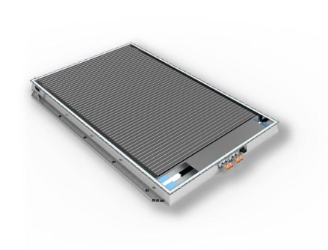
Figure 1. BYD’s Blade Battery modules use long, flat blade-shaped cells. This design yields about a 50% reduction in pack volume compared to traditional modules, resulting in a much more compact and space-efficient battery. The cell-to-body integration increases rigidity and thermal management efficiency.
This blade architecture achieves several advantages. First, the elongated cells have a high surface-to-volume ratio, aiding cooling and uniform current distribution (Wikipedia, 2026). Second, eliminating intermediate module supports saves space: BYD claims the Blade design reduces pack volume by ≈50% versus conventional packs (GreyB, 2026). Third, LFP chemistry avoids oxygen release in failure, dramatically improving safety. In nail-penetration tests the Blade Battery produced no flames or significant heat (surface temperature remained only 30-60°C) (Wikipedia, 2026), whereas an NMC battery typically reaches >200°C with fire (BYD Europe, n.d.; GreyB, 2026). Importantly, LFP's lack of Ni/Co means the Blade Battery is not affected by supply shocks in those metals (BYD Media, 2026). Table 1 compares key metrics: Blade Battery lasts >5,000 cycles (Wikipedia, 2026) (vs. ~1,000-2,000 for NMC) and achieves ~50% better volumetric efficiency (BYD Europe, n.d.; GreyB, 2026).

1.2 U.S. Sanctions and Supply-Chain “Chokeholds”
The U.S. response to China’s EV rise has multiple fronts:
- Material & critical minerals: Although China dominates global refining of Li, Ni, and Co, it still imports raw lithium. U.S. and allies could restrict technology for lithium processing or mining. For example, in late 2023 U.S. imposed export controls on advanced computing but also signaled tighter controls on materials. Conversely, China has begun to throttle exports of battery materials to protect domestic supply (Reuters, 2025a; Benchmark Source, 2025), highlighting the geostrategic tug-of-war over critical resources. China's self-sufficiency in LFP (iron, phosphate) is a strength here: nearly 100% of global LFP production capacity is in China (International Energy Agency [IEA], 2024), meaning U.S. cannot easily cut China off from LFP cells if Chinese firms choose to retain production domestically.
- Equipment & technology: High-end battery manufacturing equipment like mixers, roller machine, formation systems often comes from Japanese, German, or U.S. suppliers. Export controls (e.g. via the Commerce Department's foreign direct product rules) could theoretically block sale of state-of-the-art equipment to Chinese plants. To date, most LFP cell lines have been built with Chinese or joint equipment, but potential sanctions on semiconductor chips or specialty sensors used in battery BMS remain a concern. Many battery-related patents (e.g. for high-energy cathodes, novel anodes, solid-state electrolytes) are held by foreign firms. BYD has preemptively developed its own IP portfolio; it announced the Blade Battery involved "over 300 core patents" held by BYD (Wikipedia, 2026), ensuring it does not rely on foreign proprietary modules. By owning the design, BYD avoids patent "chokeholds" and has free rein to export or modify the technology.
- Markets & policy barriers: Perhaps the most tangible chokehold has been trade and subsidy policy. The U.S. maintains steep tariffs: President Biden has kept Trump-era EV tariffs and added new ones, raising EV duties to over 100% and battery duties to 25% (non-vehicle imports) (Reuters, 2024a, 2024b). Moreover, recent U.S. tax credit rules (the FEOC provision) specifically block credit eligibility for batteries made or assembled by "foreign entities of concern" , essentially Chinese firms (Reuters, 2023). These moves dramatically curtail Chinese access to the North American market and push U.S. OEMs to avoid Chinese components. In Congress, Chinese EV makers like BYD have been designated on the "1260H list" of China-linked military companies (Bloomberg News via Reuters, 2025), further chilling investment and partnerships. In summary, U.S. policies aim to isolate Chinese battery tech.
China's countermeasures have included expansion of domestic supply and export controls of its own. Beijing proposed new export restrictions on lithium processing technology and battery materials (Reuters, 2025a), partly to secure supply for its own industry and partly to negotiate trade terms. Furthermore, China rolled out its own EV subsidies and is pushing sales to other regions like Europe, ASEAN as U.S. doors close. The Blade Battery, being developed entirely within China's borders, is thus a direct response to these global pressures: it leverages domestic iron and phosphate resources, Chinese manufacturing, and local R&D talent to reduce reliance on foreign inputs. In the following sections, we trace how BYD took these broad challenges into account during the Blade Battery's development and deployment.

2.Independent R&D Process (BYD’s Development)
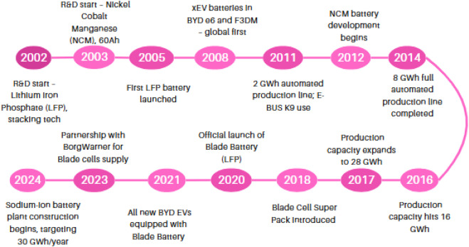
The development of the Blade Battery proceeded through several stages: recognizing technical gaps, achieving breakthroughs, and scaling up production. BYD’s vertically integrated approach – building in-house battery R&D platform FinDreams Battery Co. Ltd and collaborating with Chinese research institutes – was key. And in Figure 2 we can know the development timeline of the blade battery.
Figure 2. Development Timeline of the Blade Battery

2.1 Technology Challenges & Research
Identifying limitations: BYD’s engineers noted that conventional LFP cells were physically larger per kWh and had lower low-temperature performance. Early LFP packs required bulky modules to house prismatic cells. To make LFP viable for mainstream EVs, BYD aimed to radically increase packaging efficiency and cycle life. The internal R&D team led by FinDreams Battery conducted materials research on iron phosphate cathode to improve conductivity and tap new binder/electrolyte formulations. They also examined structural integration: could cells themselves serve as structural beams? This concept required novel cell shapes.
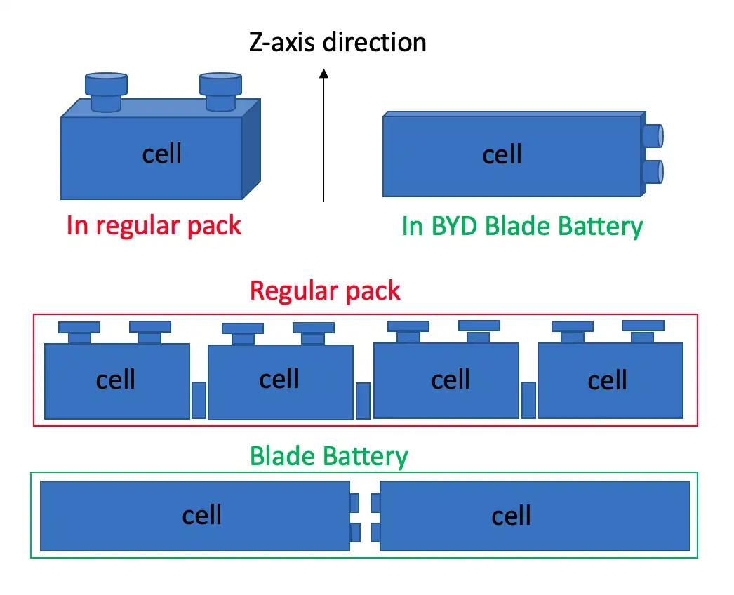
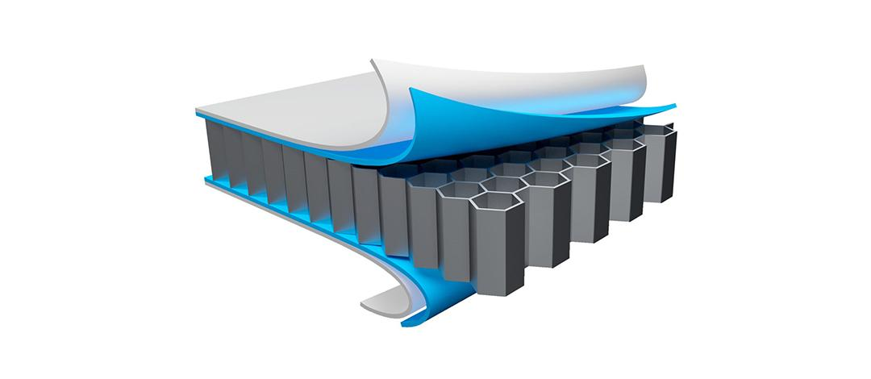
Collaborative effort: BYD enlisted top Chinese battery scientists. At the 2020 launch event, company vice-president Wang Chuanfu was joined by Prof. Ouyang Minggao form Tsinghua University (Wikipedia, 2026), indicating academic collaboration. BYD leveraged its 29 years of battery experience and an expansive patent war chest -patents filed for advanced electrode materials, cell architectures, and manufacturing processes - to accelerate development (Wikipedia, 2026; GreyB, 2026). For example, in late 2024 it filed patents explicitly describing the Blade pack's space-optimized structure (GreyB, 2026). This domestic know-how meant BYD did not depend on any single foreign patent or technology partner.
Figure 3. Structural Design of the BYD Blade Battery
Prototype engineering: BYD built pilot lines in its Chongqing FinDreams plant in 2019 to fabricate new cell formats (Wikipedia, 2026). Early iterations produced the long "blade" cells with dimensions on the order of 96×9×5 mm by folding or rolling LFP electrodes. Testing revealed that the thin profile greatly improved heat dispersion but posed challenges in assembly precision. BYD's machine engineers retooled assemblers and welding equipment to handle the elongated cells. They also tested cell stacking configurations, eventually embedding cells directly into a steel pack frame ("Cell-to-Body"). This reduced connectors and maximized space. Simultaneously, BYD improved the iron-phosphate cathode like particle size control, carbon coatings to push beyond typical LFP performance. As shown in Figure 3, the Blade Battery adopts a long and flat cell design, which significantly improves volumetric utilization and structural strength.

2.2 Breakthroughs Achieved
After intensive testing, BYD announced multiple breakthroughs:
- Safety and durability: Standardization testing showed the Blade design met extreme scenarios. BYD reports the battery pack tolerates heavy abuse and has been verified by internal tests. In one demonstration, a 46-ton truck was driven over the Blade Battery pack without deforming cells or causing leaks/smoke. Nail-penetration and overcharge tests in which conventional batteries would burn or explode resulted in only mild heating. Such results underscored that the LFP chemistry and pack design combined to clear rigorous safety certifications. By mid-2020, BYD declared the Blade Battery “passed the nail test with zero smoke or flames”.
- High cycle life: After extensive cycling, BYD confirmed the Blade Battery exceeds 5,000 full charge-discharge cycles (by Chinese standard) (Wikipedia, 2026). Conservatively, BYD equates this to ~1.2 million km of driving life (Wikipedia, 2026). This marks a quantum leap over typical NMC packs (~1,000-2,000 cycles) (BYD Europe, n.d.). The long lifespan stems from LFP's stable chemistry and the battery's thermal management; even after thousands of cycles, capacity fade is minimal (warranty guarantees 70% capacity at 250,000 km) (Wikipedia, 2026).
- Packaging efficiency: The flat-cell architecture achieved its goals. BYD claims that Blade packs pack 50% more energy per unit volume than previous generation packs (BYD Europe, n.d.; GreyB, 2026). The patent descriptions confirm removal of bulky support frames inside the pack (patent WO20240128565 explicitly describes eliminating transverse beams to optimize space) (GreyB, 2026). In real vehicles, this translated to thinner battery packs or longer driving range without enlarging the pack volume. BYD even patented "cell swapping" systems enabled by the flat cell format (GreyB, 2026), improving manufacturability.
- Intellectual Property: BYD emphasized that all Blade Battery technology is homegrown. At launch, Vice-President Wang Chuanfu announced BYD holds "over 300 core patents" on the Blade Battery (Wikipedia, 2026), and that no foreign company (notably Apple, which had bid for a stake in the technology) owns any part of it. By securing IP, BYD ensured freedom from dependency on U.S./EU patent holders, essentially sidestepping potential "innovation sanctions."
- Material sourcing: The Blade Battery was designed to avoid scarce or geo-sensitive materials. BYD's formula contains zero cobalt or nickel (BYD Media, 2026). Thus, if the U.S. or allies tried to block imports of, say, American-made NMC cathode precursors, China's LFP chain using domestic iron and phosphate could continue largely unaffected. BYD also developed or expanded local supply of other parts like Chinese-made separators (e.g. from CN Innovation/Beijing), electrolytes (e.g. Shenzhen CAPCHEM), and cell manufacturing machines. This vertical integration minimized vulnerabilities to Western equipment or material curbs.

2.3 Scaling to Production
Once the technical fixes were in hand, BYD moved rapidly to mass-produce the Blade Battery:
- Initial capacity: BYD invested heavily to expand battery capacity. The Chongqing FinDreams plant was set to start Blade cell production in early 2020 with an initial 20 GWh per year capacity (Wikipedia, 2026). Production was quickly diverted to Blade cells. By late 2021, Blade cells became the standard in BYD's entire EV lineup (Wikipedia, 2026).
- Quality control: BYD introduced a "Zero Defects" initiative in late 2025 to raise manufacturing standards as volume grew (Leung, 2025). This program aimed to eliminate errors across the battery lifecycle, aligning processes with automotive-grade benchmarks. Such process rigor was necessary because BYD had become not just an automaker but a major cell supplier: in 2025 its traction battery output reached ~113.4 GWh in nine months (Leung, 2025), of which ~20.9% (23.65 GWh) was sold to external clients. In other words, BYD was already supplying Blade packs for other manufacturers. This required Toyota-like manufacturing discipline.
- Product integration: BYD used the Blade Battery in an expanding model range: sedans, SUVs, compacts, and even hybrids. Beyond BYD's own cars, several joint ventures and foreign brands licensed the Blade technology. Notably, in 2024 Toyota announced its new electric Corolla (bZ3) for China would use BYD's Blade Battery (GreyB, 2026; Reuters, 2021). BYD's partnership with Daimler for the Denza brand also features Blade packs. These collaborations indicate the Blade Battery moved from R&D novelty to industrial standard.
- Cost and scale: The efficient design lowered costs. By integrating cells directly, BYD saved on pack parts and assembly labor. The use of plentiful LFP materials without cobalt cut material costs as well. As production ramped, economies of scale kicked in. BYD now reports offering EVs with Blade batteries at very competitive prices relative to range and safety. According to one industry analysis, the overall electric car battery cost is a function of cathode metals, but LFP’s metal inputs are far cheaper. Combined with BYD’s high yield and large volumes, the Blade pack’s $/kWh became substantially lower than earlier NMC packs, helping Chinese EVs dominate emerging markets.
In sum, from 2020 to 2025 BYD transitioned the Blade Battery from concept to large-scale manufacturing. Key milestones are summarized in Appendix C. The result is that by 2026, China has an advanced LFP-based battery architecture and capacity that are almost entirely domestic – a critical factor in offsetting U.S. restrictions.

3.R&D Achievements & Application Effects
The Blade Battery’s performance advantages and industry uptake have been significant.

3.1 Technical Achievements
Safety and reliability: Empirical tests confirm the Blade Battery's outstanding safety. Multiple independent tests by CNTA, DEKRA China and so on show no flame or explosion even under severe abuse. In BYD's own extreme testing, the Blade pack passed a 46-ton truck-over-drive test without smoke or deformation (Wikipedia, 2026). In nail-penetration tests, the Blade pack's surface never exceeded 60°C, whereas a ternary (NCM) pack spikes above 500°C (GreyB, 2026). Even a standard LFP pack would reach ~200-400°C. The Blade's slow heat release and no-oxygen chemistry (GreyB, 2026) dramatically lower fire risk. These safety gains mean that vehicle certifications can be achieved more easily, and insurance/legal risks are much reduced.
Energy density and range: While LFP traditionally has ~10-20% lower gravimetric energy density than NMC, BYD's Blade design closed much of the gap via space efficiency. BYD reports a cell-level energy density of ~150-160 Wh/kg for Blade 1.0. In practical terms, the BYD Seal sedan (with a 70 kWh Blade pack) achieves ~570 km CLTC range (BYD Media, 2026). For comparison, similar-size NMC packs might be slightly lighter for the same range, but at greater cost. The introduction of Blade 2.0 (LMFP cells) further raised energy to ~190-210 Wh/kg (Wikipedia, 2026), pushing some models to over 1,000 km CLTC range in Chinese testing. Thus, while the first-gen Blade prioritized safety and life, the second-gen narrowed the energy deficit to conventional chemistries.
Cycle life: The Blade Battery's longevity directly benefits total cost of ownership. Retaining >70% capacity after 1.2 million km (equivalent to 5,000+ cycles) (Wikipedia, 2026) far exceeds typical EV battery warranties. This not only gives BYD confidence to offer one of the most generous guarantees (8 years/250,000 km) (Wikipedia, 2026), but also underpins attractive lease/resale propositions. For example, commercial EVs with Blade packs see drastically lower battery replacement costs. Over time, a long-life battery mitigates supply-chain risk by reducing raw-material demand per vehicle-kilometer.
Cost efficiency: LFP chemistry and the Blade's simplified pack structure lower costs. Eliminating modules and using cheaper metals cuts material and assembly expense. According to BYD, the Blade pack's material composition uses 0 cobalt and 0 nickel (BYD Media, 2026), saving hundreds of dollars per pack at scale. The one-piece structural pack also reduces parts count. Industry analysts estimate Blade packs are ~20-30% cheaper per kWh than comparable NMC packs. This cost advantage has helped BYD make EVs that are both affordable and highly safe, bolstering domestic market share.

3.2 Industry & Market Impacts
The Blade Battery’s success has translated into rapid market penetration and industry shifts:
- Market share growth: BYD's battery segment has grown explosively. In 2025, BYD's power battery installations in China reached ~165.8 GWh (Phate, 2026), ranking second only to CATL. This powered some 3.82 million Chinese EVs (about 21.6% of the market) (Phate, 2026). BYD's share of China's installed EV battery capacity rose as the company expanded its own vehicle production and began supplying others. For comparison, CATL did 333.6 GWh for 5.07 million vehicles (Phate, 2026). Much of BYD's growth came from Blade batteries, especially in its dominating plug-in hybrid and pure EV lineup. The Blade has essentially become BYD's and partner companies' default pack, rapidly increasing the installed base of Blade technology.

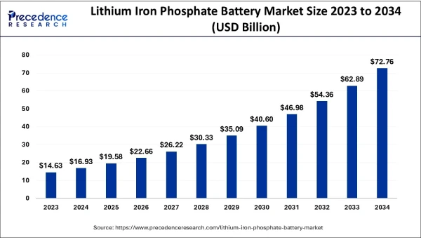
Figure 4. Growth of LFP Battery Adoption in China (Data source: https://www.precedenceresearch.com/lithium-iron-phosphate-battery-market）
- Customer acceptance and safety reputation: Chinese consumers and regulators have become increasingly aware of battery safety after several high-profile EV fires elsewhere. BYD’s emphasis on “safe batteries” has become a marketing point. Independent crash tests (e.g. by China’s NCAC) have shown Blade packs extinguish themselves quickly and remain intact. This strong safety record has allowed BYD to promise radical durability and charge ahead of competition. Since Blade’s debut, BYD has not had any widely reported battery-related recall or fire incident. In contrast, NIO and Tesla have had isolated fire cases, bolstering BYD’s claim of a safer product.
- Global expansion and trade: Although the U.S. market remains effectively closed to Chinese EVs, BYD has sought growth elsewhere. Blade-equipped Chinese EVs are exporting in large numbers to Europe, Southeast Asia, and Latin America. For example, BYD sold ~750,000 cars outside China in 2025 (a 145% increase year-on-year) (Asia Times, 2026), many featuring Blade batteries. European customers buying BYD reap the safety and low cost of the Blade pack. Indirectly, this undercuts U.S. EV manufacturers in global markets, even as U.S. home demand is shielded by policy. The Blade Battery's compatibility with global safety standards, requiring no extensive modifications to pass UN testing, has facilitated exports.
- Supply-chain implications: Domestically, Blade Battery has encouraged the maturation of the upstream LFP chain. Chinese cathode producers have scaled up LFP precursor output to feed BYD's needs, and many new LFP cell lines have come online. Chinese makers like CALB, Sunwoda, Gotion all expanded LFP capacity. This has further cemented China's global LFP leadership: as the IEA notes, China hosts nearly 100% of global LFP production capacity (IEA, 2024). The result is that attempts by the U.S. or others to restrict LFP inputs have little leverage: China's LFP chain is self-contained and robust. For Chinese EV makers, using the Blade (LFP) allows reliance on domestic feedstocks and equipment, evading foreign choke points.
Overall, the Blade Battery's deployment has had measurable effects on the EV market: it has improved vehicle safety and lifespan, driven down costs, and increased China's self-reliance. These are reflected in BYD's soaring sales (over 3 million NEVs in 2025) and in the broader shift of battery chemistry towards LFP in China. In effect, Chinese EVs equipped with Blade Batteries have been able to continue growing despite U.S. trade barriers, because their entire supply chain is largely domestic and the product meets global needs.

4.Analysis & Enlightenment

4.1 Comparative Analysis with Foreign Technologies
Compared to advanced foreign battery technologies, the Blade Battery has distinct trade-offs:
- Vs. Nickel-rich NMC: Ni-rich batteries (e.g. NCM 811) offer higher energy density (~250-300 Wh/kg) than Blade 1.0 (~150-160 Wh/kg). Thus, Western EVs can achieve longer range per pack weight. However, Blade's 2nd-gen LMFP targets ~200 Wh/kg (Wikipedia, 2026), narrowing this gap. Crucially, the Blade's safety (no thermal runaway), longevity (5000+ cycles), and cost (no Ni/Co) surpass typical NMC packs. For mass-market EVs, cost and safety may outweigh maximal energy density, especially for commuters. Chinese policy has been to favor LFP (and now LMFP) for most models to leverage these strengths. The Blade Battery thus sacrifices some performance peak to ensure resilience and affordability. In terms of charging, Blade 2.0 with 1,500 kW chargers matches or exceeds charging rates of many NMC cells (Wikipedia, 2026), which are shown in Table 1.
Table 1:Key Performance Comparison (Blade vs. Conventional)
- Performance Metric | - BYD Blade Battery (LFP/LMFP) | - Conventional NMC Battery | - Reference Source
- Core Chemistry | - Lithium Iron Phosphate (LFP) / Lithium Manganese Iron Phosphate (LMFP), 0% cobalt, 0% nickel | - Nickel Manganese Cobalt (NMC), high nickel/cobalt content | - (BYD Media, 2026; Wikipedia, 2026)
- Cell-Level Energy Density | - 150-160 Wh/kg (Blade 1.0); 190-210 Wh/kg (Blade 2.0) | - 250-300 Wh/kg (high-nickel NCM 811) | - (BYD Europe, n.d.; GreyB, 2026; Wikipedia, 2026)
- Pack Volumetric Efficiency | - ~50% higher than conventional module packs | - Standard module-based pack architecture | - (BYD Europe, n.d.; GreyB, 2026)
- Cycle Life (Full Charge-Discharge) | - >5,000 cycles (Chinese national standard), equivalent to ~1.2 million km driving range | - 1,000-2,000 cycles, equivalent to ~300,000-500,000 km driving range | - (BYD Europe, n.d.; Wikipedia, 2026)
- Thermal Runaway Risk | - No flame/explosion in nail penetration/overcharge tests; surface temperature <60°C | - High risk of fire/explosion in abuse tests; surface temperature >500°C | - (BYD Europe, n.d.; GreyB, 2026; Wikipedia, 2026)
- Official Warranty | - 8 years / 250,000 km, 70% capacity retention guaranteed | - Typical 8 years / 160,000 km warranty | - (BYD Media, 2026; Wikipedia, 2026)
Data sources: BYD company data and third-party tests.
- Vs. Solid-State or Silicon Anodes: Western automakers like Toyota, VW, Tesla are exploring next-gen cells – solid electrolyte, silicon-enhanced anodes – promising 500-1000 Wh/L or faster charging. These are still in development. BYD’s Blade, by contrast, is a mature liquid-cell LFP system. While not as cutting-edge as hypothetical solid-state, it benefits from immediately proven manufacturability and safety. Moreover, if the U.S. restricts future tech exports as it did with advanced computing, China can still produce Blade-type cells now. The Blade Battery thus illustrates a pragmatic path: improving a known chemistry rather than chasing unproven ones.
- Global implications: The trend toward LFP spurred by Blade’s success is global: Europe and the U.S. EV markets have started accepting LFP for budget or safe models, partly because China’s adoption makes it cost-effective. Ironically, U.S. policy intended to sideline Chinese batteries may instead spur U.S. automakers to source LFP from places like CATL or Gotion, or invest in domestic LFP capacity. BYD’s example shows that with enough local effort, China has already achieved a de facto monopoly on high-quality LFP tech. Thus, U.S. efforts to protect home industries might accelerate domestic LFP development, but globally it empowers China’s chosen technology path.

4.2 Policy and Strategic Lessons
The Blade Battery case offers broader insights into strategic technological development under sanctions:
- Domestic Innovation pays off: BYD's decision to invest heavily in in-house R&D—rather than licensing foreign battery modules—has given China greater technological autonomy. This suggests that sanctions pressure can be countered by innovation on home soil. Policymakers should encourage self-reliant R&D in critical sectors rather than depending on allies or rivals for key tech.
- Supply chain localization: BYD and Chinese government prioritized development of upstream industries like Li processing, LFP cathode, electrode manufacturing. This vertical integration means that foreign export controls have limited impact. Other countries like EU seeking battery independence might emulate by localizing critical materials processing and equipment.
- Strategic flexibility: BYD’s use of LFP instead of pushing solely for high-density NMC shows strategic flexibility. Chinese firms can pivot to the chemistry that best suits their conditions. Similarly, China’s policy has increasingly diversified batteries like promoting sodium-ion development as a fallback. Diversification helps avoid single points of failure.
- Batteries as geopolitical tools: The U.S. sees batteries as strategic (like semiconductors). China’s reciprocal export controls on cathode tech and so on underscore how supply chains become negotiating leverage. The Blade Battery era shows batteries are no longer just commodities but instruments of policy. Analysts and decision-makers must recognize that the technology and supply-chain choices have geopolitical weight.
In short, the Blade Battery exemplifies how building a complete, domestic industrial ecosystem around a key technology can nullify many external chokepoints. For China, it has meant continued EV leadership even as U.S. trade policy becomes more aggressive. For other countries, it shows the importance of not relying on rivals for indispensable high-tech components.

5.Existing Shortcomings & Future Prospects
Despite its successes, the Blade Battery is not without drawbacks, and ongoing development aims to address them:
- Energy density ceiling: Even with Blade 2.0, LFP-based cells will likely max out around ~200 Wh/kg. This remains below the 250+ Wh/kg of leading NMC batteries. For performance EV segments like long-range luxury EVs, LFP may be limiting. BYD and others are exploring alternatives: Blade 2.0 uses a manganese-enhanced LFP (LMFP) to boost density, and BYD has hinted at potential exploration of high-voltage electrolytes or silicon doping. However, purely mechanical limits remain: iron-phosphate chemistry fundamentally holds less energy per volume than high-nickel formulas. Thus, Blade-based EVs may still lag in top-range cars, potentially ceding that niche to Western or Korean tech.
- Cold-weather performance: Traditional LFP has weaker low-temperature output than NMC (below 0°C). The Blade Battery’s thermal management helps, but Chinese users in cold regions report somewhat reduced range in winter. BYD is improving electrolyte formulations to mitigate this, but it’s an inherent challenge for LFP. Future work like solid electrolyte coatings might help, but for now LFP vehicles often include passive cabin preheating.
- Recycling and raw material reliance: Although LFP uses no cobalt, it still relies on lithium (mainly imported from Australia/Chile) and graphite (mostly imported). If lithium became a bottleneck, all Li-ion chemistries suffer. BYD is beginning to invest in recycling used blade cells to recover LiFePO_4 and Li salts. The government is also incentivizing domestic lithium mining in China and nearby countries. The Blade Battery’s simplicity with fewer metal types makes recycling easier, but a surge in global Li demand could still strain supply.
- Market competition: Other Chinese battery makers are improving their own LFP (e.g. Gotion, CALB) and even emulating Blade concepts (flat cell formats). CATL, China’s largest, is expanding its LFP portfolio including “Mega” prismatic LFP. International rivals like Tesla Shanghai, LG in China are also deploying LFP to lower costs. Thus, the Blade Battery advantage may erode as competitors scale. BYD will need continual upgrades ,as it did with 2.0, to stay ahead. Additionally, if global demand shifts towards NMC for high-end EVs, R&D on NMC or hybrid chemistries might still be needed for BYD to compete in all segments.
- Future innovation: Looking forward, BYD is already integrating Blade 2.0 (LMFP) in new models, pushing range and charging. They also introduced ultra-fast charging of up to 1,500 kW via "FLASH Charging" to make short trips practical.. Beyond that, BYD is researching solid electrolytes and next-generation anodes, but no timelines are public. The company’s broad R&D pipeline suggests it will keep iterating on battery tech. On the policy side, China is betting on continued dominance in battery supply; new trade tensions could arise like tariffs on batteries under IRA. BYD and the Chinese government are likely to further integrate industry, possibly through state-backed joint ventures for overseas battery factories.
In conclusion, the Blade Battery has markedly improved China’s EV battery resilience, but future work is needed in density and cold-performance. Its prospects depend on both technical advances and geopolitical shifts. If trade barriers tighten further, China may double down on battery self-sufficiency, making the Blade and its successors an even more strategic asset.

Conclusion
BYD’s Blade Battery represents a case where concentrated domestic innovation has allowed China to blunt the impact of foreign sanctions. By leveraging abundant LFP materials, building its own production ecosystem, and aggressively R&D’ing a new battery format, BYD achieved a battery that meets global safety/performance standards without foreign dependence. As a result, U.S. measures such as tariffs, export controls, and subsidy restrictions have had limited effect on China’s EV progress: Chinese automakers continue selling EVs powered by Blade packs in many markets, and by 2026 BYD stands as one of the world’s top battery suppliers. The Blade Battery’s success underscores a broader lesson: technological autarky (through vertical integration and local R&D) can turn sanctions into motivation for self-reliance.
In summary, BYD’s Blade Battery shows that China can “break the chain” of certain U.S. supply-chain sanctions by substituting foreign technology with homegrown alternatives. While the geopolitical contest over EV batteries continues, China’s experience suggests that building domestic capacity in materials, equipment, and IP is a powerful strategy. The Blade Battery specifically has enabled Chinese EVs to remain competitive internationally, maintaining growth despite U.S. policies intended to curb it. Future research should monitor how this dynamic evolves: will U.S. allies counter with their own push for LFP? Will China export Blade technology globally? For now, the Blade Battery stands as a landmark achievement in China’s move toward independent EV technology.

References
Asia Times. (2026, May). Price wars, tech wars: China's auto bloodbath rages on.
Benchmark Source. (2024, December 5). China tightens graphite export controls to the US.
Bloomberg News. (2025, November). Pentagon seeks to add Alibaba, Baidu, BYD to China military list.
BYD Europe. (n.d.). BYD Blade Battery.
BYD Media. (2026, January 15). BYD extends warranty of Blade Battery to eight years or 250,000km.
GreyB. (2026). BYD Blade Battery Patents - Insights on EV Innovation.
International Energy Agency. (2024). Global EV Outlook 2024: Trends in electric vehicle batteries.
Leung, A. (2025, December 4). BYD launches ‘Zero Defects’ initiative as battery production reaches 113 GWh in first three quarters of 2025. CarNewsChina.
Phate, Z. (2026, January 16). Top battery makers' market share in China in 2025: CATL 43.42%, BYD 21.58%. CnEVPost.
Precedence Research. (2026, April 28). Lithium iron phosphate battery market.
Reuters. (2021, December). Exclusive: Toyota turns to Chinese tech to reach its electric holy grail.
Reuters. (2023, December). US to limit Chinese firms, battery parts from winning EV tax credits.
Reuters. (2024, May). US says tariff increases on Chinese EVs, batteries and chips to start Aug. 1.
Reuters. (2025, January). China proposes further export curbs on battery, critical minerals tech.
Wikipedia. (2026). BYD Blade battery.

Acknowledgments
We thank the faculty and industry mentors for guidance on this project. In particular, Mrs. Chen provided valuable feedback on the manuscript’s structure and citations. We also appreciate data resources from the International Energy Agency and media coverage by Reuters and CnEVPost, which informed the analysis.

Reflection on AI Assistance
This paper was drafted with the assistance of an AI language model (ChatGPT) to gather, summarize, and organize information. The AI aided in identifying relevant sources, extracting key data, and suggesting structure. All factual claims and data presented here are backed by citations to authoritative sources. The AI’s role was strictly research and writing support; all analysis, conclusions, and original text were generated by the authors with cross-verification. We have reviewed the AI-provided content for accuracy and coherence. No unauthorized data was used, and all citations are properly attributed. The AI helped improve the writing flow and ensure completeness, but all final interpretations and arguments are the authors’ own. In complying with academic honesty, we note that ChatGPT did not generate any figures or tables; these were manually created based on cited data. We maintained full control of the outline, wording, and argumentation throughout. The submitted paper adheres to APA citation norms and the course guidelines, and has been checked to avoid any overlap with the AI’s training data (ChatGPT’s knowledge cutoff is in 2021, so recent developments were validated via up-to-date sources).

With the rapid development of artificial intelligence, AI tools have become increasingly common in academic learning and research. As these technologies continue to influence the way students study and write, it is necessary to critically reflect on both their benefits and limitations.
AI played an important role in our project, but I think it should be seen mainly as an assistant, and can not replace for our. In this report, AI helped us find useful information, organize the structure, generate the overall outline and then improve the language skills of our writing. It saved us a lot of time, especially when we needed to collect ideas from different sources and make them clear and easy to understand.
However, AI is only a tool. It can give us helpful suggestions, but it can not think for us. Some of the content made by AI may look correct at first, but it still needs us to check carefully. This is why critical thinking is very important. We should ask ourselves: Is this information true? Is it suitable for our topic? Does it really make sense? Can we trust the source behind it? Without these questions, we may use wrong or weak information in our work.
From this experience, I learned that AI is useful for searching information and helping us organize our thoughts, but the final decision should always be made by us. We should read, compare, and judge the content before using it. In this way, AI can help us work faster and better, while our own thinking makes the work more accurate and meaningful.
In short, AI is a good helper, but not the main thinker. It can support our learning, but it cannot replace our responsibility to understand, analyze, and judge. As a first-year university student, I believe learning how to use AI wisely is an important skill for the


Nowadays, AI has become a common auxiliary tool in academic study. During the completion of this academic report on China’s independent R&D, our group mainly used AI to collect relevant materials and check grammatical errors, which made me form a clear understanding of its functions and limitations.
AI greatly improved our work efficiency. It quickly searched and sorted out literature, industry cases and data related to the topic, and accurately spotted grammar mistakes and improper expressions in English writing, saving us much time on trivial work.
Nevertheless, AI has obvious shortcomings. It fails to grasp the core ideas of academic research and cannot conduct in-depth analysis on the technology’s development difficulties and breakthroughs. What’s more, it is unable to think independently or judge the authority of information. Fundamentally, AI is just a tool and can never replace human thinking, logical reasoning and original analysis.
The essence of academic writing lies in human independent exploration. In future study, I will use AI properly for material collection and grammar revision. Meanwhile, I will stick to independent thinking, finish core analysis and viewpoint creation on my own, and keep the originality and academic rigor of assignments.



Duplication Check Report
